




[Smart Faculty Workload Management & Time Allocation System”]

Project Domain
( Excel / Power BI with Copilot)
A Project Report
submitted in partial fulfilment of the requirements of the AICW Project

by:



S Email
khannamanishamgmt@gmail.com
Faculty Name
Faculty DR MANISHA KHANNA

Guide
UmamaheshwariR

Institution:
[National PG College]

Year - 2026

ACKNOWLEDGEMENT
I would like to express my sincere gratitude to all those who contributed to the successful completion of this project.Firstly, I thank my project guide,Ms.Umamaheshwari R, for her constant guidance, valuable suggestions, and encouragement throughout the project. Her mentorship helped me stay focused and improve my work at every stage. I am also grateful to Bharti Verma Maam,Adarsh sir , Ankit Sir and Edunet Foundation, Microsoft, LinkedIn, and SAP for providing me with this valuable opportunity through the AICW Fellowship Program. The resources and learning support provided were instrumental in enhancing my understanding of AI and data analytics.
I extend my thanks to National PG Collegefor providing the necessary infrastructure and academic environment required for completing this project.Finally, I thank my family and friends for their continuous support and motivation.
ABSTRACT OF THE PROJECT
This project follows a practical and structured approach to understand and improve faculty workload distribution. The idea is to take raw data and gradually turn it into meaningful insights that can help in decision-making.
At the beginning, the data is collected in Microsoft Excel. It includes workload details of around 50 faculty members from different departments. The dataset covers various activities such as teaching, research, administrative work, mentoring, and examination duties. This helps in capturing a complete picture of faculty responsibilities.
Once the data is collected, the next step is cleaning and preparing it. In real-world data, errors and inconsistencies are quite common, so this step is very important. Missing values are checked, formats are standardized, and all entries are verified to ensure accuracy. This makes sure that further analysis is reliable.
After cleaning, the data is analyzed using Excel. Different formulas are used to calculate total workload, workload percentage, and to identify whether a faculty member is overloaded or balanced. Pivot tables are especially useful here as they help in summarizing the data and identifying patterns across departments.
The processed data is then moved to Power BI, where it is transformed into an interactive dashboard. This makes it much easier to understand the data through visuals like charts and graphs instead of raw numbers.
To make the system more advanced, Microsoft Copilot is used for AI-based insights. It helps in quickly summarizing the data, identifying unusual patterns, and even suggesting ways to improve workload distribution.
Finally, all the results are compiled into a report. This includes the analysis, dashboard insights, and AI-generated observations. The goal is to present everything in a clear and understandable way so that it can be useful for academic evaluation as well as real-world application.

TABLE OF CONTENTS

Abstract of the Project
List of Figures
List of Tables
Chapter 1 — Introduction
Problem Statement
Motivation
Objectives
Scope of the Project
Chapter 2 — Literature Survey
Chapter 3 — Proposed Methodology
3.1 System Design
3.2 Modules / Components Used
3.3 Data Flow Diagram (DFD)
3.4 Advantages
3.5 Requirement Specification
Chapter 4 — Implementation and Results
4.1 Data Cleaning Results
4.2 Visualization / Output Results
4.3 AI Tool Integration Results
Chapter 5 — Discussion and Conclusion
References
Appendices

LIST OF FIGURES

Figure No. | Figure Title / Description | Page No.
Figure 1 | [Raw / uncleaned dataset screenshot] | 14
Figure 2 | [Cleaned dataset or validation summary screenshot] | 15
Figure 3 | [Main dashboard / report / output screenshot] | 17
Figure 4 | [Additional chart or visualization screenshot] | -
Figure 5 | [AI tool (Copilot / Chatbot) in use screenshot] | -
Figure 6 | [DFD Level 0 — Context Diagram] | 12
Figure 7 | [DFD Level 1 — Detailed Process Flow] | 13

LIST OF TABLES

Table No. | Table Title / Description | Page No.
Table 1 | [Raw dataset summary — field names, data types, row count] | 14
Table 2 | [Cleaned dataset summary — issues found and fixed] | 14
Table 3 | [Hardware Requirements] | 13
Table 4 | [Software Requirements] | 13
Table 5 | [Key findings / results summary] | 20

CHAPTER 1
Introduction
1.1Problem Statement
Managing faculty workload in higher education institutions is complex due to multiple responsibilities such as teaching, research, mentoring, and administrative tasks. These activities are often recorded in separate systems or spreadsheets, leading to:
- Lack of transparency in workload distribution
- Difficulty in tracking total workload
- Manual errors and inconsistencies
- Underrepresentation of actual faculty efforts
This affects faculty satisfaction and decision-making by administrators.
1.2Motivation
The motivation behind this project is to:
- Improve transparency in workload distribution
- Reduce manual effort in data handling
- Enable data-driven decision-making
- Align with modern trends in AI and business intelligence
1.3Objectives
The main aim of this project is to develop a systematic and data-oriented framework for evaluating and improving faculty workload in higher education institutions. Instead of relying on traditional judgment-based methods, this study focuses on creating a more transparent and measurable approach to workload management.
The key objectives of the project include:
- To create a well-structured faculty workload dataset that captures a wide range of academic and non-academic responsibilities, such as teaching, research, mentoring, evaluation, and administrative duties.
- To improve the accuracy and consistency of the dataset by applying data cleaning, preprocessing, and validation techniques using Microsoft Excel.
- To define and calculate important performance metrics like total workload, workload percentage, and workload status, ensuring a standardized way of measuring faculty effort.
- To perform a detailed analysis of workload distribution across faculty members and departments in order to identify imbalances, excessive workload, and inefficiencies.
- To build an interactive and user-friendly dashboard in Power BI that allows stakeholders to easily monitor workload patterns and support better decision-making.
- To incorporate artificial intelligence tools, particularly Microsoft Copilot, for generating automated insights, identifying irregularities, and suggesting improvements in workload allocation.
- To design a flexible and scalable workload management model that can be adopted by higher education institutions to enhance fairness, transparency, and overall efficiency.

1.4 Scope of the Project
The scope of this project is focused on analyzing and improving faculty workload management using data analytics and visualization tools. It involves the creation of a structured dataset representing various faculty responsibilities and applying analytical techniques to evaluate workload distribution.The project is limited to a simulated dataset of faculty members and does not involve real-time data integration from institutional systems. The analysis is carried out using tools such as Microsoft Excel and Power BI, along with AI support from Microsoft Copilot for generating insights.The system is designed to provide a clear understanding of workload patterns, identify imbalances, and suggest possible improvements. However, it does not include automated workload allocation or direct integration with institutional databases.Overall, the project serves as a practical model that demonstrates how data-driven methods and AI tools can be used to enhance decision-making in academic workload management.

CHAPTER 2
Literature Survey
2.1 Existing Work
Existing workload management systems often rely on manual processes or disconnected tools. While some institutions use spreadsheets or basic dashboards, these solutions lack integration and advanced research.Following study has been done-
Ramya & Muthumari (2024): Found that administrative and committee responsibilities significantly affect faculty performance, especially when expectations are unclear. They recommend quantifying service roles to balance teaching and research.
Al-Samarraie & Saeed (2018) develop and evaluate a faculty-load management system aimed at improving the quality, transparency, and fairness of workload allocation; their study demonstrates that systematic, data-driven allocation mechanisms reduce inequities and better reflect the full scope of academic duties. The study’s findings emphasize that non-teaching tasks (committees, administration, mentoring, outreach) are often underestimated in conventional models, and that explicit inclusion of these tasks in allocation systems reduces hidden overload and supports equitable distribution.
Dhanapal, S., & Subramaniam, R. (2019). Explored faculty members’ lived experiences of workload using a phenomenological qualitative method, with emphasis on how workload shapes teaching practice and professional well-being. The study attempted to identify the specific sources of workload pressure (teaching, administrative duties, committee work, research expectations) and how these are perceived and negotiated by faculty. The study found that Non-teaching duties (administration, committees, mentoring) were frequently experienced as invisible or undervalued work that reduced time for research and preparation, negatively affecting teaching quality. The study concluded that institutional support, clearer workload policies, and transparent allocation mechanisms are necessary to mitigate stress, improve job satisfaction, and protect research time.
Houston, D., Meyer, L. H., & Paewai, S. (2006) investigate how academic workloads relate to job satisfaction, focusing on expectations, values, and the balance of teaching, research, and service; they conclude that mismatches between institutional expectations and individual values contribute to dissatisfaction and that transparent, balanced workload arrangements improve staff morale and performance.
O’Meara et al., 2019 said Faculty members are increasingly engaged in diverse activities such as research, mentoring, administrative duties, and institutional service, making workload inherently multidimensional.Several studies emphasize that the lack of a comprehensive workload measurement system leads to inaccurate representation of faculty effort. When non-teaching responsibilities are not adequately accounted for, institutions risk overburdening certain faculty members while underutilizing others. This imbalance not only affects individual performance but also impacts organizational efficiency and fairness according to Mushabe et al., 2022.In recent years, there has been a shift toward data-driven approaches in workload management. Researchers suggest that the use of structured datasets and analytical tools can significantly improve the accuracy and transparency of workload assessment. Business intelligence tools such as Power BI enable institutions to visualize workload patterns and identify imbalances effectively ,according to Ludwig-Beymer, 2024.Additionally, the integration of artificial intelligence in data analytics has introduced new possibilities for automating workload analysis. AI tools can assist in generating insights, detecting anomalies, and supporting decision-making processes. However, existing literature indicates thatthe practical application of AI tools such as Microsoft Copilot in faculty workload management is still limited and underexplored.
Despite the availability of analytical tools and theoretical frameworks, many institutions continue to rely on manual or semi-structured systems for workload allocation. These approaches lack scalability, consistency, and real-time insight generation. Therefore, there is a clear need for integrated systems that combine data analytics, visualization, and AI capabilities.
The present project addresses this gap by developing a structured workload dataset, applying Excel-based analysis, creating interactive dashboards using Power BI, and integrating AI-assisted insights through Microsoft Copilot. This approach aligns with emerging trends in data-driven decision-making and provides a practical, scalable solution for faculty workload management.
Despite the availability of analytical tools and theoretical frameworks, many institutions continue to rely on manual or semi-structured systems for workload allocation. These approaches lack scalability, consistency, and real-time insight generation. Therefore, there is a clear need for integrated systems that combine data analytics, visualization, and AI capabilities.
The present project addresses this gap by developing a structured workload dataset, applying Excel-based analysis, creating interactive dashboards using Power BI, and integrating AI-assisted insights through Microsoft Copilot. This approach aligns with emerging trends in data-driven decision-making and provides a practical, scalable solution for faculty workload management.

2.2 Tools and Technologies Review
- Microsoft Excel
Used for organizing, cleaning, and transforming data, along with performing basic visual analysis. Features such as pivot tables, conditional formatting, and data validation are extensively applied to structure and interpret the dataset.
- Microsoft Power BI
A business intelligence platform that enables the creation of dynamic and interactive dashboards. It allows users to visualize data effectively and generate insights without requiring advanced technical expertise.
- Microsoft Copilot (AI)
An AI-powered assistant embedded within Microsoft 365 applications that supports automation, summarization, and data interpretation using natural language queries, enhancing productivity and analytical efficiency.
- AI Chatbots (ChatGPT, Gemini)
Generative AI tools utilized for drafting reports, creating content, generating marketing material, and performing prompt-based analytical tasks.AI Chatbots support prompt-based analysis and content generation.

2.3 Gaps Identified
- Inadequate Workload Measurement Models
Current studies largely emphasize teaching hours while overlooking other critical faculty responsibilities such as mentoring, administrative work, and evaluation tasks, leading to an incomplete assessment of workload.
- Insufficient Attention to Workload Distribution Equity
Although imbalance in workload is widely recognized, there is a lack of practical systems that ensure fair and balanced allocation of responsibilities among faculty members.
- Limited Adoption of Data Analytics Tools
Despite the availability of tools like Excel and Power BI, many institutions continue to depend on manual or semi-structured approaches instead of leveraging data-driven techniques for workload analysis.
- Low Integration of Artificial Intelligence
The use of AI tools, particularly Microsoft Copilot, in faculty workload management is still emerging, with minimal real-world implementation for insight generation and decision support.
- Absence of Real-Time Monitoring Systems
Existing systems do not provide dynamic or real-time tracking of workload, making it difficult for institutions to quickly identify and address imbalances.
- Disconnect Between Theory and Practice
While theoretical models and frameworks are well-documented, there is a shortage of simple, scalable, and user-friendly solutions that can be implemented effectively in academic environments.
Overall Observations
Existing research tends to focus on complex machine learning models, while simpler and more practical tool-based approaches for non-technical users are not sufficiently explored.
There is limited evidence of integrating AI tools like Copilot with Excel and Power BI for domain-specific applications, particularly in student projects.
Standardized frameworks for prompt engineering in business contexts are still under development.

CHAPTER 3: Proposed Methodology
This chapter outlines the approach adopted to meet the objectives of the project, including system architecture, functional modules, data flow, benefits, and system requirements.

3.1 System Design
- The proposed system follows a structured and data-centric framework to evaluate and optimize faculty workload. It converts raw data into actionable insights through a series of stages, including data collection, preprocessing, analysis, and visualization. This ensures a smooth transformation from input data to meaningful output that supports informed decision-making.
- Input Data Source
- The system uses a structured dataset developed in Microsoft Excel, containing workload information for approximately 50 faculty members across multiple departments. The dataset includes various workload components such as teaching hours, research activities, administrative tasks, mentoring duties, examination responsibilities, evaluation work, and meeting hours. This dataset is designed to reflect realistic academic workload scenarios.
- Data Cleaning
- Before analysis, the dataset is preprocessed to ensure accuracy and consistency. This involves identifying and correcting missing or inconsistent values, standardizing numerical formats, and verifying that all workload parameters are properly recorded. This step ensures that the dataset is reliable and suitable for further analysis.
- Data Analysis and Processing
- The cleaned dataset is analyzed using Excel and Power BI. In Excel, formulas are applied to compute key metrics such as total workload, percentage workload, and workload classification (e.g., balanced or overloaded). Pivot tables help summarize and identify trends across departments and faculty members.
- Power BI is then used to build a structured data model, enabling deeper analysis through measures and aggregations. Additionally, Microsoft Copilot assists in generating insights, identifying anomalies, and suggesting workload optimization strategies.
- Visualization and Output
- The results are presented through an interactive Power BI dashboard featuring charts, graphs, and key performance indicators. These visuals help users easily interpret workload distribution and identify imbalances. Overall, the system demonstrates how integrating data analytics and AI tools can effectively enhance faculty workload management.

3.2 System Modules
The system is divided into multiple modules, each responsible for a specific function within the data processing pipeline:
Module 1: Data Collection and Ingestion
This module handles the input of faculty workload data stored in Excel. It ensures that all relevant information is structured in a tabular format for easy processing.
Module 2: Data Cleaning and Preparation
This stage focuses on improving data quality by checking for errors, inconsistencies, and missing values, ensuring that the dataset is accurate and standardized.
Module 3: Data Analysis and Computation
In this module, Excel is used to calculate key workload metrics such as total workload, workload percentage, and workload status. Pivot tables assist in summarizing and identifying trends.
Module 4: Visualization and Dashboard Creation
Power BI is used to create interactive dashboards that display workload insights through various visual elements, enabling easy interpretation and comparison.
Module 5: AI-Based Insight Generation
Microsoft Copilot is integrated to provide automated summaries, detect patterns, and offer recommendations for workload distribution, enhancing analytical depth.
Module 6: Reporting and Documentation
The final module compiles all findings, visualizations, and AI-generated insights into a well-structured report suitable for academic submission.

3.3 Dataflow diagrams
Main System Flowchart
Start
↓
Data Collection (Excel Dataset)
↓
Data Cleaning & Preprocessing
↓
Data Analysis (Excel Formulas + Pivot Tables)
↓
Data Modeling (Power BI)
↓
AI Insight Generation (Copilot)
↓
Dashboard Visualization (Power BI)
↓
Report Generation
↓
End

Module-Based Flow Diagram
[Data Ingestion]
↓
[Data Cleaning & Preprocessing]
↓
[Data Analysis & Computation]
↓
[Visualization (Power BI Dashboard)]
↓
[AI Insights (Copilot)]
↓
[Final Report]

Data Flow Diagram (DFD - Simple)
Faculty Data (Excel)
↓
Processing Layer
(Cleaning + Analysis)
↓
Storage / Model (Power BI)
↓
Output
(Dashboard + Report + AI Insights)

3.4 Advantages
- Reduces manual effort
- Improves accuracy
- Provides clear insights
- Supports decision-making
- Scalable and cost-effective

3.5 Requirement Specification
- Laptop — Intel Core i5 or higher, minimum 8 GB RAM
- Operating System: Windows 11
- Microsoft 365/Excel
- Power BI Desktop
- Microsoft Copilot
- AI Chatbot (ChatGPT / Google Gemini / Microsoft Copilot Web)
- Internet connection — required for Copilot and AI Chatbot access
- Web browser — Google Chrome

CHAPTER 4
Implementation and Results
4.1Data Cleaning Results
Original Dataset Structure
The raw dataset contained the following columns:
- Faculty ID
- Faculty Name
- Department
- Teaching Hours
- Research Hours
- Administrative Duties Hours
- Mentoring Hours
- Evaluation/Exam Duties Hours
- Meeting Hours
Original Dataset Size
- Rows: 50
- Columns: 9
- 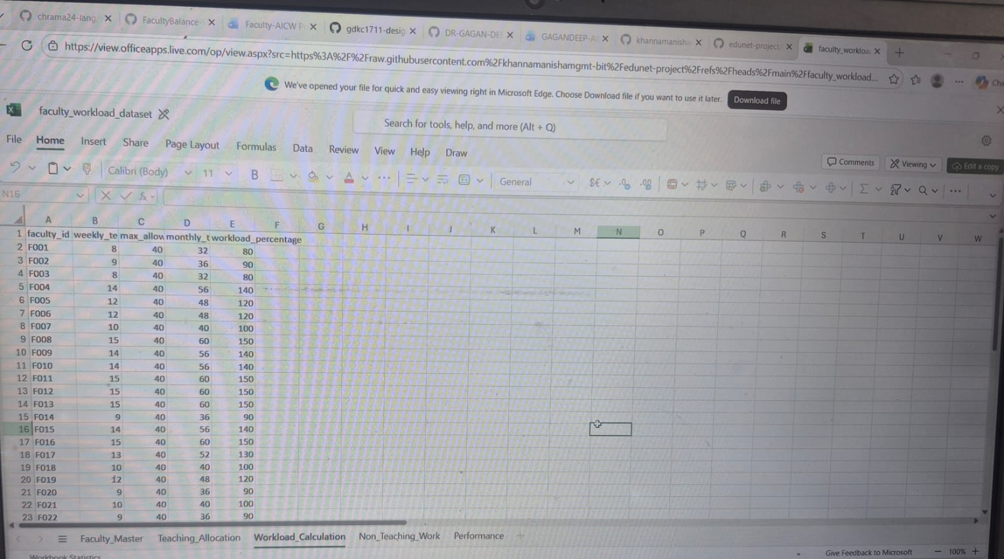
Issues Identified
During initial inspection, several data quality issues were found:
- Missing values in columns like Research Hours and Meeting Hours
- Numerical fields stored as text format
- Inconsistent naming in the Department column (e.g., "CSE", "Comp Sci")
- Some incorrect or extreme values due to manual entry errors
- Minor misalignment of data across columns
Data Cleaning Steps Applied
The dataset was cleaned using the following steps:
- Handling Missing Values
Missing entries were replaced with appropriate values such as averages or zeros where applicable.
- Data Type Conversion
All workload-related columns were converted into numeric format to enable accurate calculations.
- Standardization of Department Names
Department names were made consistent (e.g., all entries converted to “Computer Science”, “Mechanical”, etc.).
- Error Correction
Outliers and incorrect values were identified and corrected based on logical limits.
- Data Validation
Excel data validation rules were applied to ensure all entries fall within acceptable ranges.
- Data Alignment
The dataset was reorganized to ensure that each column correctly represents its respective attribute.
Cleaned Dataset Size
- Rows: 50
- Columns: 9
(No records were removed; only corrections were made)
Before vs After Data Cleaning (Sample Table)
Faculty Name | Department (Before) | Department (After) | Teaching Hours (Before) | Teaching Hours (After) | Research Hours (Before) | Research Hours (After)
A. Sharma | CSE | Computer Science | 12 | 12 | — | 5
R. Verma | Comp Sci | Computer Science | "15" (text) | 15 | 6 | 6
P. Singh | ME | Mechanical | 20 | 18 (corrected) | 4 | 4
S. Gupta | ECE | Electronics | — | 10 | 5 | 5
Summary
After cleaning, the dataset became fully consistent, with:
- No missing values
- Correct data formats
- Standardized categories
- Accurate and aligned entries
This ensures that further analysis and visualization in Excel and Power BI produce reliable and meaningful insights.

4.2 Visualization / Output Results (Detailed Dashboard Explanation)
The Power BI dashboard titled “Smart Faculty Workload Management” is designed to provide a comprehensive, interactive, and user-friendly representation of faculty workload distribution across various academic and non-academic activities. It enables stakeholders such as administrators, HR personnel, and faculty members to understand workload patterns clearly and make informed decisions.
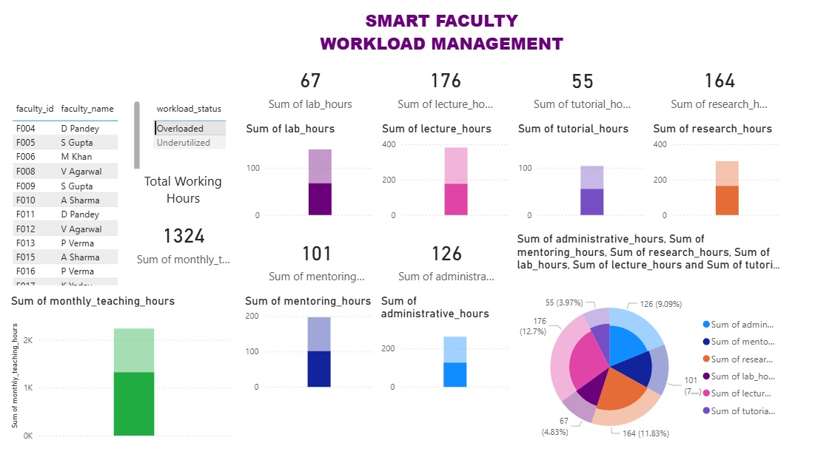
Total Metrics Overview (KPI Cards)
The dashboard displays key performance indicators (KPIs) at the top, summarizing the total workload across different activity categories.
Lab Hours (67 Hours)
This metric represents the total number of hours faculty members spend conducting laboratory sessions. Lab sessions usually require preparation, supervision, and evaluation, making them time-intensive. Although lower compared to lecture hours, lab hours still contribute significantly to the overall teaching workload.
Lecture Hours (176 Hours)
Lecture hours form the largest component of the teaching workload. This indicates that faculty members are heavily engaged in classroom teaching activities. A high number of lecture hours may suggest increased teaching responsibilities, which can impact time available for research and administrative work.
Tutorial Hours (55 Hours)
Tutorial sessions involve personalized teaching, doubt-solving, and student interaction. These hours reflect additional academic support provided by faculty beyond lectures. Though fewer in number, tutorials are crucial for improving student understanding and academic performance.
Research Hours (164 Hours)
Research hours represent the time spent on academic research, publications, and project supervision. A substantial value here indicates active involvement in research activities, which is essential for institutional growth and academic excellence.
Total Working Hours (1324 Hours)
This is the aggregated workload across all categories, including teaching, research, mentoring, and administrative duties. It provides a holistic view of the total effort contributed by faculty members over the given period.

Activity-wise Bar Charts
The dashboard includes separate bar charts for each activity category, allowing detailed comparison and analysis.
Lab Hours Chart
This chart visually represents the distribution of lab hours among faculty members. It helps identify which faculty are more involved in practical teaching and whether lab responsibilities are evenly distributed.
Lecture Hours Chart
The lecture hours chart highlights the dominance of classroom teaching in overall workload. It allows administrators to identify faculty members handling excessive lecture loads, which may require redistribution.
Tutorial Hours Chart
This chart provides insight into student support activities. It helps determine whether tutorial responsibilities are fairly assigned or concentrated among a few faculty members.
Research Hours Chart
The research chart helps evaluate faculty engagement in scholarly activities. It can reveal imbalances where some faculty focus heavily on research while others are more teaching-oriented.

Mentoring and Administrative Work
In addition to teaching and research, the dashboard highlights other important responsibilities:
Mentoring Hours (101 Hours)
Mentoring includes guiding students, supervising projects, and providing academic and career advice. This component reflects the faculty’s role in student development beyond classroom teaching.
Administrative Hours (126 Hours)
Administrative work includes committee participation, documentation, scheduling, and institutional responsibilities. A high administrative workload may reduce the time available for teaching and research.
These metrics ensure that all aspects of faculty contributions are considered, not just teaching.
Monthly Teaching Hours Analysis
The dashboard includes a visualization of monthly teaching hours, which shows how workload varies over time.
Helps identify peak workload periods, such as exam seasons or semester beginnings
Reveals trends and patterns in teaching activities
Assists in future planning and workload balancing
This temporal analysis is useful for understanding workload fluctuations and improving scheduling.
Workload Classification (Overloaded vs Underutilized)
A key feature of the dashboard is the classification of faculty into:
Overloaded Faculty
These are faculty members whose workload exceeds a defined threshold. Overloading can lead to stress, reduced productivity, and lower teaching quality.
Underutilized Faculty
These faculty members have comparatively lower workloads. Identifying underutilization helps redistribute tasks more effectively.
This classification helps administrators:
Ensure fair workload distribution
Improve faculty satisfaction
Optimize resource utilization

Pie Chart — Overall Workload Distribution
The pie chart provides a consolidated view of how total workload is distributed across different activities:
Teaching (Lectures, Labs, Tutorials)
Research
Mentoring
Administrative Work
Insights from the Pie Chart:
Teaching activities form the largest portion of workload
Research contributes significantly but is secondary to teaching
Administrative and mentoring tasks also occupy a notable share
This visualization makes it easy to understand the relative importance of each activity at a glance.

Overall Insights from Dashboard
The dashboard provides several actionable insights:
Teaching dominates workload, especially lecture hours
Research involvement is significant, but varies across faculty
Administrative work is unevenly distributed, indicating potential inefficiencies
Some faculty are overloaded, while others are underutilized
Workload distribution lacks uniformity, highlighting the need for better planning

CHAPTER 5
Discussion and Conclusion
5.5 Conclusion
This project successfully demonstrates the application of data analytics and AI tools in solving real-world problems in academic institutions. By integrating Excel, Power BI, and Microsoft Copilot, the project provides a structured approach to managing faculty workload.
The interactive dashboard enables stakeholders to visualize workload distribution clearly and identify imbalances. The use of AI tools further enhances the efficiency of analysis by generating quick insights and summaries.
All project objectives were achieved, including data cleaning, analysis, visualization, and AI integration. The system developed is scalable and can be extended to include real-time data and predictive analytics in the future.
Overall, the project contributes to improving efficiency, transparency, and fairness in faculty workload management and demonstrates the practical value of AI and business intelligence tools in the education sector.

REFERENCES

1. Microsoft Corporation. Microsoft Excel Documentation. Available at: https://support.microsoft.com/en-us/excel
2.Microsoft Corporation. Power BI Documentation. Available at: https://learn.microsoft.com/en-us/power-bi/
3.Microsoft Corporation. Microsoft Copilot — AI-Powered Productivity. Available at: https://copilot.microsoft.com
4. Edunet Foundation. AICW Fellowship Program Guidelines. 2026.
5. O’Meara, K., Kuvaeva, A., & Nyunt, G. (2019). Faculty workload equity: A review of research and implications for practice. Journal of Higher Education.
6. Mushabe, C., Nansubuga, F., & Ssekiziyivu, B. (2022). Reconceptualizing faculty workload as a measure of motivation and performance. Social Sciences & Humanities Open.
7. Ramya, R., & Muthumari, S. (2023). Impact of workload and role expectations on faculty performance in higher education institutions.
8. Ludwig-Beymer, P. (2024). Data-driven approaches to faculty workload management.
9.Kaggle Inc. Open Datasets. Available at: https://www.kaggle.com/datasets
10.LinkedIn Learning. AI and Data Analytics Courses. 2026. Available at: https://www.linkedin.com/learning
11.Websites of higher education institutes of lucknow

APPENDICES

Appendix A — Sample Dataset


